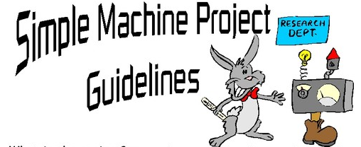

Future Engineers from Rose Park

What is the project? You need to create a working machine that uses TWO or more simple machine (lever, wedge, inclined plane, wheel and axle, gear, pulley and screw). Your project must be able to complete a simple task- work (move an object over a distance when force is applied). The object being moved is called the load.

The simple machine(s) you use and the load being moved must be labeled. All machines help us overcome forces in nature, friction and/or gravity, to make our job easier.

Must be able to explain what each simple machine is doing to overcome natural forces.

The project must be student made, using simple household items (empty cans, cardboard tubes, string, paper clips, CDs, etc.).

The project is due Thursday, February 21st

Rubrics: (up to max points)
On Time 10 pts
Use of simple machine 20 pts
Labeled Parts 20 pts
Complexity 20 pts
Project performs simple task 30 pts

BE CREATIVE

CHECK OUT- RUBE GOLDBERG PROJECTS for examples

