Human Body Test Review Guide
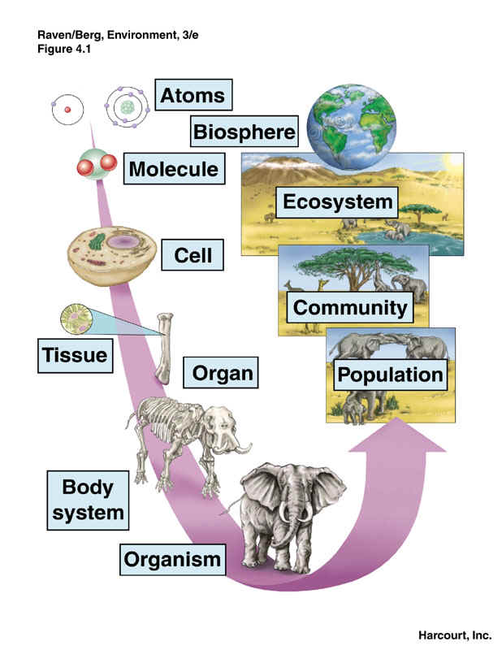
Levels of Organization
- Cell – smallest unit of a living thing
  - Organelles – make up cells, cannot live on own
- Tissue – Group of similar cells working together
- Organ – Group of tissues that perform a specific function
- Organ system – group of organs that perform a specific task
- Organism – living thing

What’s Happening Inside
- Organ – A group of tissues that performs a specialized task.
- Structure – Organization, construction and arrangement of tissues, parts or organs.
- Organ Systems – Group of organs performing similar task
  - Digestive – break down and absorption of food and nutrients
  - Respiratory – exchange of oxygen and carbon dioxide
  - Excretory – removal of liquid waste
  - Circulatory – transport of food and nutrients around body
  - Nervous – responding to environment, control
  - Skeletal – support and protect body
  - Muscular – help body move
  - Endocrine – produce and release hormones to regulate body
  - Immune and lymphatic – help body fight disease and infections
  - Reproductive – produces sex cells and allow for reproduction
- Homeostasis (AKA regulation, maintain equilibrium)
  - Processes in body to help keep a stable internal environment
    - Ex. Sweating when hot, taking in O₂ and removing CO₂, insulin to control blood sugar

