Pulley’ing Your Own Weight

Procedure
- Attach one end of the string to the object you will be lifting using a paperclip.
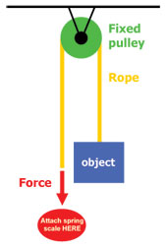
Figure 1. Fixed pulley
- Weigh the object by hooking the paper clip at the other end of the string to the hook on the spring scale. Carefully raise the spring balance until the object is hanging freely (about 1 inch off the table). Record this value on question 3 of your observation sheet. Also record the force required to lift the object without a pulley.
- Create a fixed pulley. Place a single pulley on the middle ring of the stand. Thread the short string over the pulley wheel. Hook the left paper clip to the object, which is placed on the #1 written on the stand base. Attach the spring scale upside down to the right paper clip.
- Have one student hold the pulley still and another pull the spring scale down gently until the object lifts off the platform (approximately 1 inch), as shown in Figure 1.
- Keep the tension on the spring scale and record the force needed (measurement on the spring scale) in the table on question 4 of you observation sheet.
- Next, create a movable pulley by attaching the pulley to the object (see Figure 2). Attach the pulley to the object (sitting on the #1 on the stand base) using the bottom hook of the pulley. While one student holds the pulley by the top hook, thread the short string through the pulley and connect one end to the top left hook on the stand.
- Connect the spring scale to the other end of the string. One student holds the string in place while another student lifts the object by pulling up on the spring scale string, as shown in Figure 2. Lift the object slowly until it is approximately 1 inch off the platform.
- Draw a diagram of what your moveable pulley looks like in question 1 of your observation sheet. Be sure to label all parts and the forces.
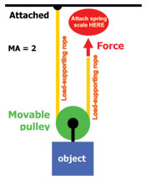
Figure 2. Movable pulley
- Observe how much force is required to lift the object (spring scale measurement) and record it in the table on question 4 of your observation sheet.
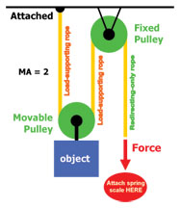
- Last, create a pulley system. Run the long string through the fixed pulley and then through the movable pulley, which has the object (sitting on the #3 on the stand base) attached to it, as in Figure 3. Using a paper clip, attach one end of the string to the upper left hook on the stand.
- Have one student hold the fixed pulley, while another student raises the object by gently pulling down on the spring scale.
Figure 3. Pulley system.
- Record the force required to lift the object (spring scale measurement) with this two-pulley system in the table on question 4 of your observation sheet.
- Draw a diagram of what your moveable pulley looks like in question 1 of your observation sheet. Be sure to label all parts and the forces.
- Answer question 5 on your observation sheet.

Observation Sheet
In the drawing of a fixed pulley, below, notice the location of the weight and applied force.
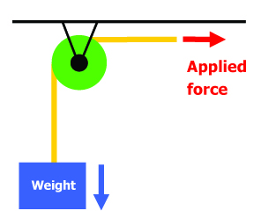

- Draw a movable pulley (string, pulley, weight) and label the forces (weight, applied force).

- Draw a two-pulley system with one movable pulley and one fixed pulley. Label the forces.

- What is the weight of the object you will lift? Remember to indicate the units.

_________________________

- How much force is required to lift the object in each test case?
Read the spring scale and record in the table, below.

Object Being Weighed | Force Needed to Lift?
Object alone
Object with fixed pulley
Object with movable pulley
Object with two-pulley system

- Write a paragraph comparing how much force is needed to raise the object in all four cases. Your paragraph should be at least three sentences long.

