Name:_________________________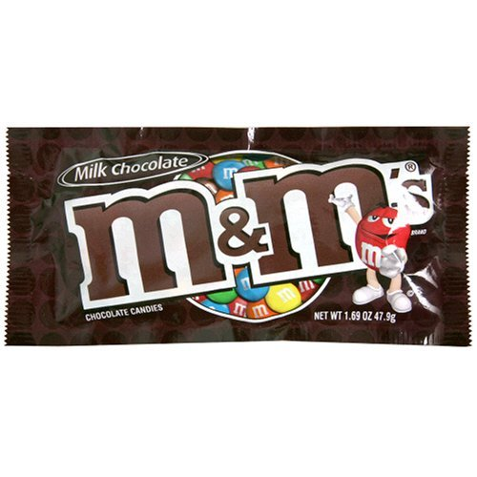
Date:_______________
Period:______________
M&M Lab
The scientific method is a way to think about problems and a way to solve problems. Scientists do not always follow the steps of the scientific method in order. However after a problem is solved, a scientist can use the scientific method to explain how the solution was reached. The scientific method can be broken down into the following parts:
- State the problem.
- Gather information.
- Form a hypothesis.
- Experiment.
- Record and analyze data.
- State a conclusion.
Introduction
In this activity, you will follow the steps of the scientific method to discover how many candies of each color are in a given amount of M&M’s. This lab shows you how scientists record data on charts, make graphs, and draw conclusions. Do not eat any of the candies until I tell you because it will affect your results. Do not begin until instructed to do so.
Objectives
- Name and describe the steps of the scientific method.
- Follow the steps of the scientific method to solve a problem.
- Record data in a table or chart.
- Construct a graph that shows the results of the investigation.

Materials
47.9 g of M&M’s in a cup (or package of M&M’s)
Pencil
Paper towel or plate
Lab sheet with chart to record individual data and class data
Colored pencils to match candy colors

Research/Prediction
- State the problem. (Hint: What are you trying to find out?)
______________________________________________________________________________
- Gather information (It is unlikely that you will find any information about colored candies in the library. Probably your best sources of information are experts, people with experience with colored candies. You are the experts. Look at the candies. What colors are found?
___________________________________________________________________________
- Predict which color do you think will be the most common? __________________________
- Form a hypothesis. Write a statement that tells how many candies you think will be in the cup?
____________________________________________________________________________
- Predict how many of each color will be in the cup/bag.
Red-________Orange-_________Yellow-________Green-________Blue-______Brown-______

Procedure
- Experiment. No eating! Sort the M&M’s by color.
- Pour the M&M’s onto a clean paper towel or paper plate.
- Count the number of M&M’s of each color. Record in the frequency column.
- Add all the numbers in the frequency column and record the total number of candies at the bottom of the column.
- Calculate the percentage of each candy color. (Divide the number of each color by the total number of candies).
Color | Frequency | Percent
Red
Orange
Yellow
Green
Blue
Brown
 | Total:

- Record the totals and % of color for the class in the table below.

 | Red | Orange | Yellow | Green | Blue | Brown
Totals
% of color

- Make 2 bar graphs for each data set (your group and the class) on a separate piece of graph paper. Use color, label both axis and include a title.

Questions
- What was the most common color in your group? How do you know it was the most common? ______________________________________________________________________________
______________________________________________________________________________

- What was the most common color for the class?
______________________________________________________________________________
______________________________________________________________________________

- Were your results exactly like the class results? If not what would account for the differences? ______________________________________________________________________________
______________________________________________________________________________

- The M&M/Mars Company produces the following ratios for plain M&M’s: 30% brown, 20% yellow, 20% red, 10% orange, 10% blue, and 10% green.
Were your group ratios and the class ratios (percents) close to this? Why do you think you did not get exactly the same ratios?
__________________________________________________________________________________________________________________________________________________________________________________________________________________________________________

