Mitosis Song and Dance (sung by the “Chromatids”)
the tune just kind of goes bum-bum-bum-bum-bum-bum—sort of like a heart beat

Interphase!
(milling around to find your partner)

Prophase!
We replicate ourselves
(one partner steps out from behind the other)
And form a chromosome
(hold the wrists of your “sister chromatid”)
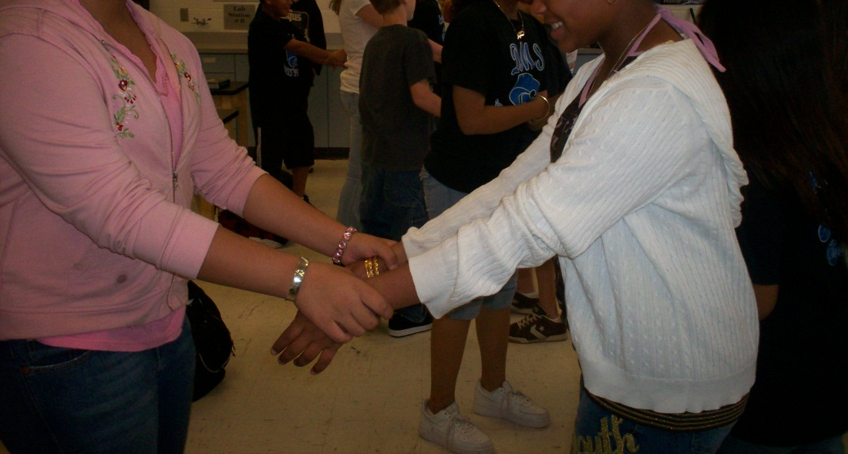
Metaphase!
We line up in the center
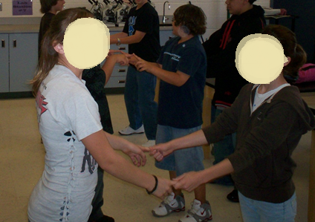
(chromosomes form straight line in center of room)

Anaphase!
We separate apart
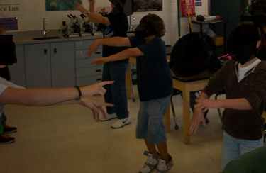
(students take one step away from partner and drop hands)

Telophase!
We move far away
(students back away from each other)
a new nucleus forms
(wrap arms around self in a hug)
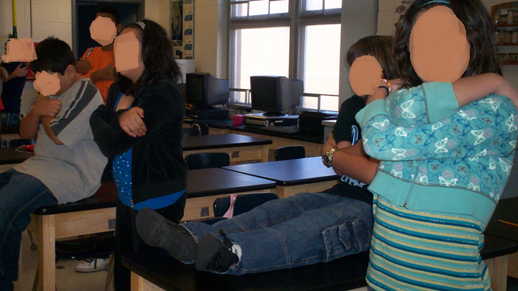

Cy—to—ki—ne--sis!
(move very far apart)

