**Genes and Disease**

**Content**

The Human Genome Project (HGP) has created the field of genomics --understanding genetic material on a large scale. The medical industry is building upon the knowledge, resources, and technologies from the HGP to improve understanding of genetic contributions to human health.

BD20085_[1]**Diagnosing and Predicting Disease and Disease Susceptibility**   
All diseases have a genetic component, whether inherited or resulting from the body's response to environmental stresses like viruses or toxins. The successes of the HGP have even enabled researchers to pinpoint errors in genes--the smallest units of heredity--that cause or contribute to disease.

The ultimate goal is to use this information to develop new ways to treat, cure, or even prevent the thousands of diseases that afflict humankind. But the road from gene identification to effective treatments is long and fraught with challenges. In the meantime, biotechnology companies are racing ahead with commercialization by designing diagnostic tests to detect abnormal genes in people suspected of having particular diseases or of being at risk for developing them.

**Disease Intervention**   
As research continues, medical scientists will figure out how faulty genes play a role in causing disease. The potential for using genes themselves to treat disease--gene therapy--is the most exciting application of DNA science. It has captured the imaginations of the public and the biomedical community for good reason. This rapidly developing field holds great potential for treating or even curing genetic and acquired diseases, using normal genes to replace or supplement a defective gene or to bolster immunity to disease (e.g., by adding a gene that suppresses tumor growth).

**Gene Mutation**

Cells can sometimes contain changes or variants in the information in their genes. This is called **gene mutation**, and it often occurs when cells are aging or have been exposed to certain chemicals or radiation. Fortunately, cells usually recognize these mutations and repair them by themselves. Other times, however, they can cause illnesses, such as some types of [cancer](http://kidshealth.org/teen/diseases_conditions/cancer/deal_with_cancer.html). And if the gene mutation exists in egg or sperm cells, children can inherit the mutated gene from their parents.

Researchers have identified more than 4,000 diseases that are caused by genetic variants. But having a disease gene doesn't always mean that you will get a disease. Because you inherit a gene from each parent, having one disease gene usually does not cause any problems because the normal gene can allow your body to make the normal protein it needs. On average, people probably carry from five to 10 variant or disease genes in their cells. Problems arise when the disease gene is dominant or when the same recessive disease gene is present on both chromosomes in a pair. Problems can also occur when several variant genes interact with each other - or with the environment - to increase susceptibility to diseases.

**Dominant and Recessive Genes**

If a person carries the dominant gene for a disease, he or she will usually have the disease and each of the person's children will have a 1 in 2 (50%) chance of inheriting the gene and getting the disease.

People who have one recessive gene for a disease are called carriers, and they don't usually have the disease because they have a normal gene of that pair that can do the job. When two carriers have a child together, however, the child has a 1 in 4 (25%) chance of getting the disease gene from both parents, which results in the child having the disease. [Cystic fibrosis](http://kidshealth.org/teen/diseases_conditions/digestive/cystic_fibrosis.html) (a lung disease), [sickle cell anemia](http://kidshealth.org/teen/diseases_conditions/genetic/sickle_cell_anemia.html) (a blood disease), and Tay-Sachs disease (which causes nervous system problems) are caused by recessive disease genes from both parents coming together in a child.

Some recessive genetic variants are carried only on the X chromosome, which means that usually only guys can develop the disease because they have only one X chromosome. Girls have two X chromosomes, so they would need to inherit two copies of the recessive gene to get the disease. X-linked disorders include the bleeding disorder [hemophilia](http://kidshealth.org/teen/diseases_conditions/blood/hemophilia.html) and color blindness.

Sometimes when the egg and sperm unite, the new cell gets too many or too few chromosomes. Most children born with Down syndrome, which is associated with mental retardation, have an extra chromosome number 21.

In some cases, people who are concerned that they might carry certain variant genes can have genetic testing so they can learn their children's risk of having a disease. [Pregnant women](http://kidshealth.org/teen/your_mind/emotions/pregnancy.html) can also have tests done to see if the fetus they are carrying might have certain genetic illnesses. Genetic testing usually involves taking a sample of someone's blood, skin, or amniotic fluid, and checking it for signs of genetic diseases or disorders.

This article is reprinted from the Human Genome Project Information site at: <http://www.ornl.gov/sci/techresources/Human_Genome/medicine/medicine.shtml>.

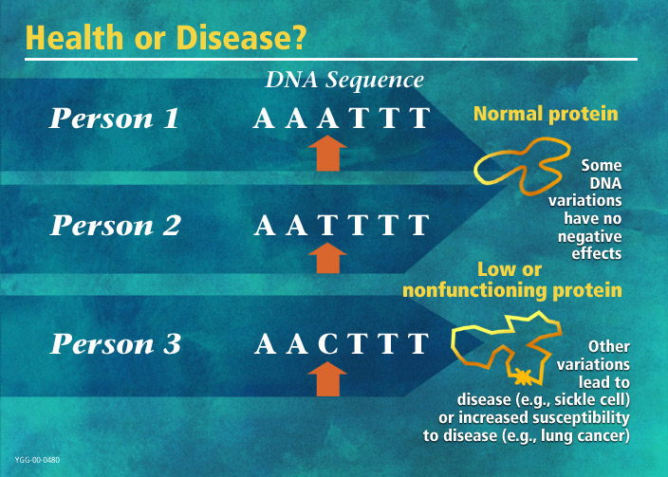

**image credit:** U.S. Department of Energy Human Genome Program, http://www.ornl.gov/hgmis.