Do Plants Consume or Release CO₂?

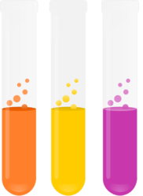
1. Background
In this lab, you will use phenol red as an indicator to show whether CO₂ is being consumed or produced in a reaction within plants.
It is well known that in the presence of light plants perform photosynthesis. It is less well understood that at the same time plants are also performing cell respiration. To demonstrate this we will determine whether CO₂ is consumed or produced as elodea is placed in either a light or dark environment. The change in CO₂ will be detected by the pH indicator phenol red.
Think about the chemical equations for respiration and photosynthesis. Which one releases CO₂ causing an increase and which one uses up CO₂ which will cause a decrease?
Phenol red is yellow under acidic conditions (high H ion concentration), pink under basic or alkaline conditions (low H ion concentration) and orange under neutral conditions. A change in CO₂ will cause a directly proportional change in H ion.
- If the CO₂ concentration decreases, the H ion concentration will also decrease and the solution will change to pink, becoming basic.
- If the CO₂ concentration increases, the H ion concentration will also increase and the solution will change to yellow, becoming acidic.
- Neutral solutions of phenol red will be orange.

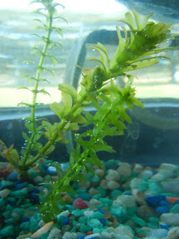
2. Preparation
You will be given a solution of phenol red mixed with water. Your goal is to make your solution a neutral orange color. You can do this by gently blowing into the solution with a straw. Once you have the solution at an orange color, transfer it to 4 test tubes (they should be filled about 2/3 full with your orange solution).
Place a cut piece of elodea (cut end up) into two of the four tubes. The other two test tubes will not have elodea and will serve as controls. Cover one control and one experimental test tube with parafilm and place in the test tube rack in the light. Cover the other control and experimental test tube with aluminum foil and place in the dark in a test tube rack.

3. Pre-Lab Questions-

What is photosynthesis? ______________________________________________________

What living thing requires photosynthesis? __________________________________________

Where does photosynthesis occur in the plant (what part)? ____________________________

What is required for photosynthesis? _________________________________________

Where does the plant get CO₂, water and sunlight? ____________________________________

What are the products of photosynthesis? ___________________________________________

What is the purpose of the glucose? ________________________________________________

What happens to plants in the dark? _______________________________________________
Write a hypothesis about what will happen to CO₂ levels in a solution if an aquatic plant is photosynthesizing.
If ______________________________, Then _____________________________.

4. Data- Record the colors of the solutions in the test tubes after 30 minutes and 1 day.
Sample | 30 Minute Observations | 1 Day Observations
Light Control
Light with Elodea
Dark Control
Dark with Elodea

4. Analysis- In your notebook, answer the experimental question (Do Plants Consume or Release CO₂? ). Explain what happened in this lab, use complete sentences and be sure to provide supporting data or statements. Draw what each test tube look like and label them.

