Name:

DNA Structure Worksheet- Review for Test

1. What do the letters DNA stand for?

2. Two scientists are given credit for discovering the structure of DNA. What are the names of those two scientists?

a.

b.

4. The “backbone” of the DNA molecule is made up of two components. What are they?
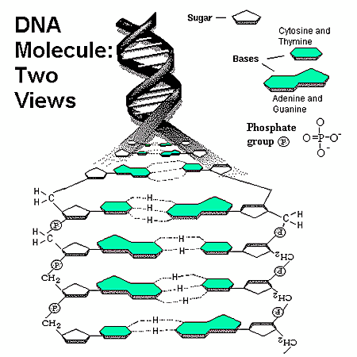

a.

b.

5. There are four different variations of these monomers (four different bases). What are the names of those bases?

a.

b.

c.

d.

Erwin Chargaff discovered that the DNA of any species contains equal amounts of adenine and thymine, and also equal amounts of cytosine and guanine.

6. Based on this information, scientists could predict that the base _______pairs with

______and the base __________pairs with ________________ in the formation of the DNA molecule.

This is called complementary base pairs, or base pair rules. One strand of DNA is complementary (opposite/matching) to the other strand.

7. The bases are paired by ___________bonds along the center of the molecule.

8. Maurice Wilkins and Rosalind Franklin studied the structure of DNA using X-ray crystallography, a technique to examine molecules, and helped Watson and Crick determined that the shape of the DNA molecule was a _________________.

9. Draw the basic structure of a nucleotide with its three parts.

10. Write the complementary sequence to following DNA strand:

A A T T C G C C G G T A T T A G A C G T T
| | | | | | | | | | | | | | | | | | | | |

11. Use the image below to complete the following:

Circle a nucleotide.
Label the sugar and phosphate.
Label the bases that are not already labeled.

