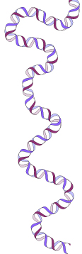
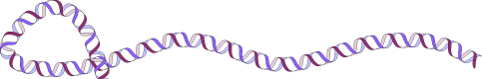
WIND YOUR WAY AROUND YOUR OWN DNA!!!

DNA contains the instructions for making an organism, including YOU! Your DNA determines how you look, what blood type you have, even your tendency to get some diseases. Almost every cell in your body contains the same DNA and same genes (some cells such as gametes have half as much DNA and mature red blood cells don’t have any DNA). Each chromosome is made of a single, long strand of DNA. If the DNA from the 46 chromosomes in one cell of your body could be laid out end-to-end, it would measure 6 feet!!!

In this activity, you will isolate your very own DNA from your cheek cells. First, you will break away the membranes surrounding the cells and nuclei, and then you will precipitate the DNA so you will be able to see your DNA!

MATERIALS NEEDED:
- clear Gatorade OR 0.9% salt water (NaCl) (approx. 1/2 teaspoon in 8 oz. water)
- small cup (4-8 oz.)
- 30 – 50 ml test tube or other small container (such as a clear film canister)
- 25% soap solution (1 teaspoon dish soap or shampoo + 3 teaspoons water)
- ice cold alcohol (95% ethanol/ethyl alcohol is best; 91% isopropanol/rubbing alcohol also works) – keep in freezer or on ice until use
- teaspoons for measuring

PROCEDURE:
- Swish 2 teaspoons (10 ml) of the salt water from the small cup in your mouth vigorously for 30 seconds. Your goal is to slough off as many cheek cells as possible. Your instructor will time you to make sure you have swished long enough.
- Spit the water with cheek cells back into the small cup.
- Pour this solution into a tube containing 1 teaspoon (5 ml) of soap solution.
- Gently mix this solution for 2-3 minutes. Try to avoid creating too many bubbles.
The soap solution breaks the cell membranes that are made up of fats – just like soap breaks down grease on your dishes!
- Tilt the tube of soap solution/cells. Pour 2-3 teaspoons (10-15 ml) of ice cold alcohol (EtOH) down the side of the tube so that it forms a layer on top of your soapy solution. DO NOT MIX THIS!!
- Let the tube stand for 1 or 2 minutes.
- The white clump that you see is YOUR DNA!!!!! Research laboratories use a similar procedure to isolate and study DNA from different organisms.
~~~~~~~~~~~~~~~~~~
BEOP is funded by a grant from the Howard Hughes Medical Institute.
Our community outreach program is also supported by the UIUC Biotechnology Center.

